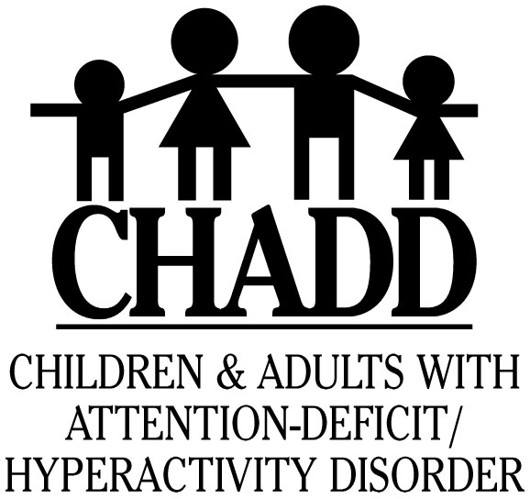

AD/HD SUPPORT GROUP

CHADD CARES

CHADD works to improve the lives of people affected by AD/HD through:

Collaborative Leadership

Advocacy

Research

Education and

Support

www.chadd.org

Do You or Someone You Know Have Attention Deficit/Hyperactivity Disorder?

Do You Want to Learn More
about AD/HD?

JOIN US
at
[Location]

[1st/2d/3rd/4th xxx of the month]

at [time]

For more information contact:

CONTACT:

Do You Have a Child

