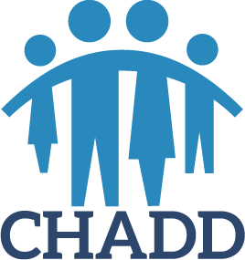

**YOUNG SCIENTIST RESEARCH AWARDS**

**2024 Recommendation Form**

Children and Adults with Attention-Deficit/Hyperactivity Disorder (CHADD), a national non-profit 501(c)(3) organization, is pleased to announce the continuation of the Young Scientist Research Awards for significant contributions to the on-going understanding of ADHD.

**Applicants must be in the process of completing a doctoral degree or have completed one within the last three years with the doctoral degree awarded no earlier than January 2021. They must be involved in conducting research addressing an area of ADHD that will further understanding of the disorder.** The research may address any area relevant to ADHD, including, but not limited to

-biological/genetic underpinnings of the disorder

-treatment efficacy

-impact on the individual or family

-school or workplace accommodations

-social stigma and discrimination

-public health

-epidemiology

A minimum of two recommendations is required.

Entries will be judged by a panel of experts in the field of ADHD, including members of CHADD’s Professional Advisory Board and CHADD’s Board of Directors.

**All information will remain strictly confidential.**

**Applicant’s name:** ___________________________________________________________

**Research study title:** _________________________________________________________

**Your name:** _________________________________________________________________

**Professional Affiliation**: _______________________________________________________

**Your address:** _______________________________________________________________

**Daytime phone:** (______)____________________

**Evening phone:** (______)____________________

**Your e-mail address:** ______________________________________________________

**Applicant’s e-mail address:** _________________________________________________

**On a separate sheet, please answer the following questions:**

1. **How long have you known the applicant?**
2. **Have you worked with or supervised the applicant? Please explain.**
3. **Are you familiar with the applicant’s research? Please explain.**
4. **If the applicant is currently enrolled in a doctoral program, do you think he/she will complete the program? Please explain.**
5. **Applicant’s strengths?**
6. **Applicant’s capacity to make significant long-term contributions to the research field?**
7. **Additional comments?**

Signature _____________________________________ Date _____________

**Please email the completed form to** [**youngscientist@chadd.org**](mailto:youngscientist@chadd.org)**.**

**Application deadline: Close of business, April 2, 2024**

[**www.chadd.org/research**](http://www.chadd.org/research)